Student J

Grader J

Project 1

Well done! No errors!

Here's the code in jGrasp:

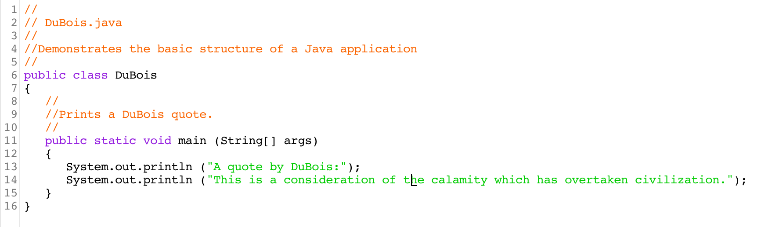

And here's the output when it runs:

